

**Message from the Executive Director**

**Mr. Cortland Purks:**

Dear Parents,

As the school year comes to an end, we have worked very hard to ensure that you child is kindergarten ready.

We wish you much success in the future. For those returning we will see you in September. Have a safe and happy summer.

**Cortland Purks**

Cortland Purks

Executive Director



***Holy Cross Head Start Inc.***

***Spring/Summer 2017 ***

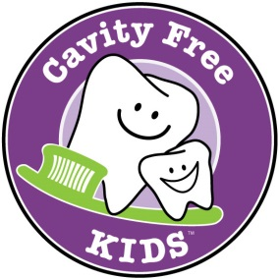**What Causes Cavities?**

* We all have germs in our mouths called “Strep Mutans” and “Lactobacilli.”
* The combination of germs and carbohydrates (sugar and starches) creates an acid that attacks teeth for up to 20 minutes.
* Plaque is a sticky film that is constantly building up on our teeth, and is made from the germs and their byproducts.
* Germs will never be completely gone from our mouths—the goal is to keep them under control by brushing and flossing.
* Repeated acid attacks on our teeth can make cavities.
* Cavities must be treated by a dentist.

**Cavities are Preventable!**

* Cavities are almost 100% preventable.
* Brush twice a day, two minutes at a time, with small amount of fluoride toothpaste—smear the size of a grain of rice until age 3, the size of a pea after that. Floss once a day as soon as teeth touch!
* Get a dental checkup twice a year. Medicaid and most dental insurance plans cover two preventive visits each year.
* Ask the dentist about fluoride varnish and sealants—they help protect the teeth from cavities.

Submitted by Chris Tedesco- Health Coordinator

Cavity Free Kids Regional Hub Leader





**Preventing the Flu: Good Health Habits Can Help Stop Germs**

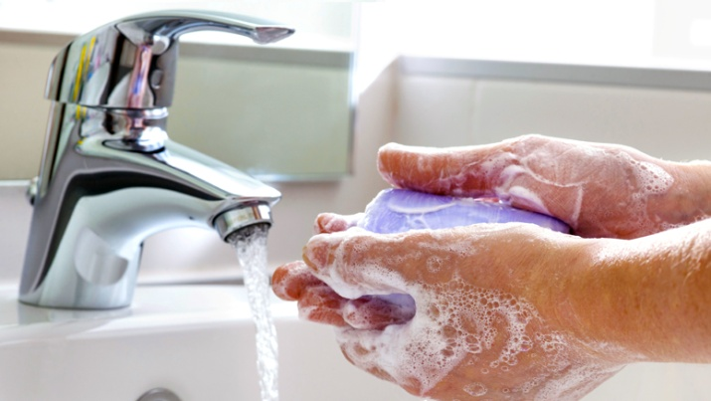The single best way to prevent seasonal flu is to get

vaccinated each year, but good health habits like

covering your cough and washing your hands often

can help stop the spread of germs and prevent

respiratory illness like the flu. There also are flu

antiviral drugs that can be used to treat and prevent

flu.

1. Avoid Close Contact:

Avoid close contact with people who are sick. When you are sick, keep your distance from others to protect them from getting sick too.

2. Stay Home When You Are Sick:

If possible, stay home from work, school, and errands when you are sick. This will help prevent spreading your illness to others.

3. Cover Your Mouth and Nose:

Cover your mouth and nose with a tissue when coughing or sneezing. It may prevent those around you from getting sick.

4. Clean Your Hands:

Washing your hands often will help protect you from germs. If soap and water are not available, use an alcohol-based hand rub.

5. Avoid Touching Your Eyes, Nose or Mouth:

Germs are often spread when a person touches something that is contaminated with germs and then touches his or her eyes, nose, or mouth.

6. Practice Other Good Health Habits:

Clean and disinfect frequently touched surfaces at home, work or school, especially when someone is ill. Get plenty of sleep, be physically active, manage your stress, drink plenty of fluids, and eat nutritious food.

For More Healthy Tips → <https://www.cdc.gov/flu/protect/habits.htm>

Submitted by: Chris Tedesco- Health Coordinator